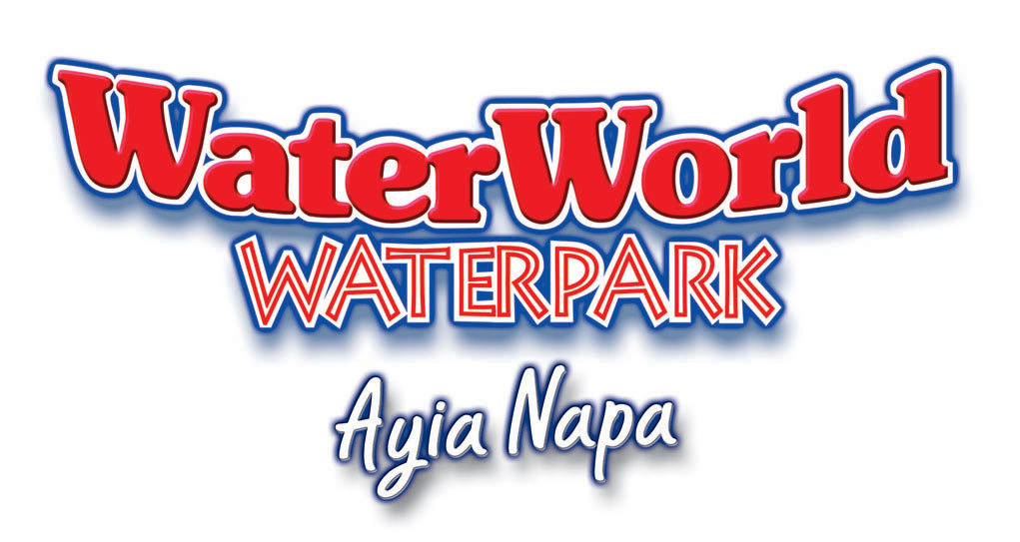STAFF APPLICATION FORM |  |  | E: admin@waterworldwaterpark.com  T: +357 23724444  F: +357 23724160
Surname: | Other Names:
Nationality: | Date of Birth:
Are you an EU Citizen? | Please specify:
Available From: Until: | Gender: | Male |  |  | Female
Post Applied For:
Address:
Telephone No: | Email:

Educational History: Give details of recent schooling & any certificates / qualifications obtained

Last Employers Name:
Address:
 | Telephone No:
Position Held: | Salary:

Medical History: Give details of severe illness, operations or accidents
Are you registered Disabled? | Yes |  | No |  | If YES please give RDP No:

Criminal Record: Give details of any criminal offences against you

Is there any other information that you feel will help your application?
Please supply two references:

In which languages are you fluent?
Who do you know at WaterWorld?
Declaration:
- I declare that the information given in this form is true & correct. I understand that any incorrect information may affect my employment
Date:

